# A00: Getting Started and Setup

* Assignment A00 should be done alone.
* To begin, go to “File” and Select “Make a Copy...”
* You should seek help completing assignment A00 from the TAs at the evening lab.

## Learning Objectives

* Learn some new terms related to computer science.
* Setup your coding environment, including your IDE and other tools.
* Practice using all of the tools we will need in this class.
* Get to know the TAs who will be supporting your learning in this course.

NOTE: While this isn’t due until next Wednesday, you’ll need PyCharm set up for Friday’s class. Don’t wait on Task 4 below!

## Tools

To be successful in this course, you will need to become familiar with using five primary tools: Google Drive, Trello, Git, Slack, and the PyCharm IDE. You will need to install some of these tools and you’ll want to explore all of them. But before you dive into the deep end, let’s make sure you have the support you need to be successful in this assignment and in this course.

### Task 1: Visit the Evening Lab

As you *surely* remember from the [syllabus](https://docs.google.com/document/d/10UJk05740Fm1wXrIxptkF4aWyDzCnnYYkR9Qp2Gb5ao/edit?usp=sharing) that you just finished reading in preparation for Friday’s quiz, you’ll know there is an evening lab in Danforth Technology Building that supports all of our CS students. The first part of this assignment is to visit the evening lab **in the next week**.

|  |  |
| --- | --- |
| **Questions and Instructions** | **Your Answers** |
| According to the syllabus, when is the evening lab open (days and times)? | 1.Sunday through Thursday 6pm to 9pm |
| Where is the evening lab located? (Which room and building?) | 2.DT Room 104 |
| Visit the evening lab at your earliest convenience. Speak with any one of the many teaching assistants at the lab. Most have taken CSC 226 and are happy to help you with the course. Ask them three or more questions of your choosing. Some examples (please don’t just ask the following three… it’ll become very boring for our TA’s to answer the same three questions 20+ times):   * Why did you pick CS as a major? * What was the most challenging part of CSC 226 for you? * What is the instructor like? | Question 1:  What is the hardest subject that you did in CSC226?  TA’s Answer 1:  Question 2:How hard was it adjusting or learning how to use all the programs?  TA’s Answer 2:  Question 3:  TA’s Answer 3: |
| The reason you are visiting the evening lab is two-fold:   1. To expose you to a valuable resource for seeking out help in this course. 2. So you can get help with the installation processes, which are coming in 3, 2, 1... | |

### Task 2: Register an Account for Google Drive

You’ve made it this far, so you’re off to a good start!

We will use Google Drive significantly in this course to collaborate. For that, you’ll need a Google account. If you don’t have an account already, [register for an account here](https://accounts.google.com).

One of the best features of Google Drive is its ability to allow multiple people to write in the same document at the same time. Most homework and teamwork assignments will be accompanied with a Google Document just like this one. Since we will be exploring Google Drive in our first teamwork, we will leave much of that exploration for later. However, some things you should explore that will help you later in this course (and life, in general):

Go to the [Google Drive website](https://drive.google.com) and explore the interface. Note the “Install Backup and Sync” link in the bottom left. Consider installing this application and putting ***all*** of your files (from now until the end of time) in the Google Drive directory that it creates. It can serve as your backup solution until you graduate, ensuring you ***never*** lose any of your work, even if your computer crashes. Ever!

For your reference, here’s a helpful [3 minute video](https://www.youtube.com/watch?v=NsKnLVi2z4o) on why and how to do the installation.

### Task 3: Visit and Review Trello, the Course Agenda

All course materials, including the syllabus, are posted on the [course website](https://trello.com/b/aAjBbbHs/csc-226-software-design-implementation-spring-2019).

**This is the course agenda. You will find all of your due dates and expectations here!**

Some notes about the agenda:

* The course agenda contains the **official due date** of all course materials. Dates don’t get updated in Moodle, because it is **only being used for grading purposes.** You should ignore Moodle except to look up your grades and attendance.
* **We will update the Trello site regularly.** You should check it regularly. If a due date gets extended, it will be announced here and/or on Slack. Although we will make regular announcements in class and via email, you are responsible for knowing what is due each day. The Trello board should always be correct.
* The calendar feature in Trello is a very useful way of seeing what you have due; use it!
* You can subscribe to the Trello board so you are informed of changes via email or text message. Use this as well!

Visit the Trello site, and answer the following two questions:

|  |  |
| --- | --- |
| At what date and time is **A00: Getting Started** due? | 3.a.January 16th 11:55pm |
| According to the course agenda, when is quiz **Q00: The Syllabus**? | 3.b. 1-11-19 |
| What is the **late work policy?** (Summarize, don’t copy/paste.) | 3.c. It’s late for partial credit unless the person emails the TA and she is notified. |

### Task 4: Download and Install PyCharm IDE

To write code, typically you’ll want to use an **Integrated Development Environment (IDE)**. For this course, we will rely on the [PyCharm Community Edition (CE).](https://www.jetbrains.com/pycharm/download/)

Follow the installation instructions. You may have the option of installing Python version 2.7 or 3.7. **Install Python 3.7** or whichever subversion (3.7, 3.8, 3.x) we are at by the time class runs. *You should also install the Markdown plugin, if you are given the option during setup.*

Once you’ve installed PyCharm, play around in the interface to become more familiar with it. However, we will be exploring the interface in our first teamwork assignment, so don’t fret if it seems overwhelming at this point.

### Task 5: Download and Install Git

As part of this course, we will be introducing you to a tool often used in software engineering known as **git**. To use git, we first need to install it. [Download](https://git-scm.com/download) the appropriate git for your operating system (for the vast majority of you, it will be Windows 64-bit version). Accept all of the default values for the installation.

Git is a **version control system** for software. Ever notice how some software has a version, such as PyCharm?

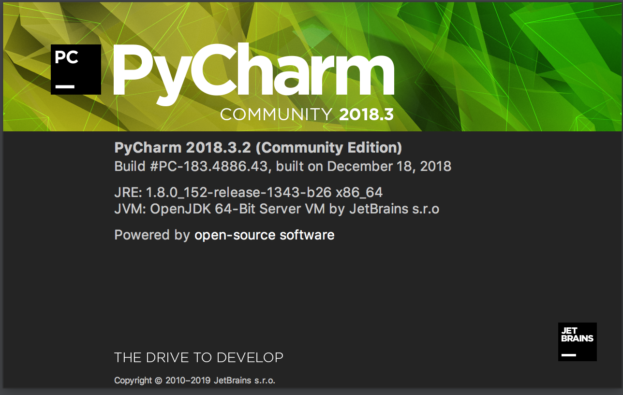

One way software engineers control this versioning is through git. Git also has another extremely powerful use for software engineers; preventing two (or more) programmers from writing code in the same file and accidentally deleting each other’s work.

Imagine you’re building a program such as the software you’re looking at right now: Google Drive. Certainly you realize that more than one developer created all this. To ensure multiple developers don’t clobber each other’s hard work, they use git to manage versions.

So, each developer **clones** all of the code, makes some changes to that code, then requests the code be incorporated in the final product. Git monitors all of the files, and when it notices two developers wrote code in the same spot, it flags those two sets of code as having a **merge conflict**. Then, the developers can discuss whose code should be kept, or modify the code so that both can be kept. By developing good communication within an organization about who is working on what features (more on this later), coupled with git as a failsafe, developers are able to produce very large programs faster, with less duplication of labor, and with less errors.

|  |  |
| --- | --- |
| Describe two or more reasons git will be useful in this course, based on what you know now?  Hint: no answer is wrong here, except for no answer. | 4.Git will be helpful sending in projects and forming teams. |

### Task 6: Set up PyCharm to use your Github Account

After Git is installed, join our [Github classroom for A00](https://classroom.github.com/a/Ldf_dmQj) (GitHub is a website that uses git plus a host of additional tools for managing code, which we’ll explore later).

Select your email address from the list. You’ll likely need to register for a Github account. Use your Berea email address (e.g., lovelle@berea.edu for me) as your username. Make your password something secure, and something you’ll remember in a few steps. You’ll need your username and password often, so do not lose it!

Follow the remaining prompts until you arrive at the main page of the repository ("repo", for short). You’ll see two files: a LICENSE and a README.md file.

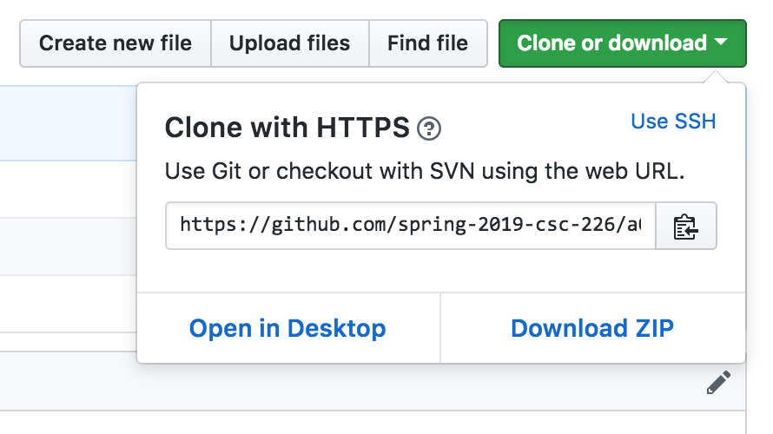

|  |  |
| --- | --- |
| Copy your repository link, by clicking the tiny clipboard icon, and paste it in the space to the right for later: | 5. https://github.com/spring-2019-csc-226/a00-getting-started-and-setup-TheGiantOof |

We’ll come back to Github. For now, head to PyCharm.

We need to change some PyCharm settings to allow Git integration. Go to your PyCharm settings (under File), and go to the **Version Control** section. Under that section, is **GitHub**. (Do not pick "Git"!) Click into it.

Configure this screen with the correct Login and Password information for your account.

Now you’ll be able to use Git and Github to manage all your code, work collaboratively with other students in the class, and never lose your code because it’s saved in Github!

### Task 7: Using Git in PyCharm

Now, let’s access our first repository in PyCharm. You’ve already created the repository in GitHub, and the link to that repo is above in Question 5.

Go to PyCharm. If you are not at the “Welcome to PyCharm” screen, click File >> Close Project which should take you to the welcome screen. On the welcome screen, click the “Check out from Version Control >> Git” option.

Paste the link from Question 5 in the URL box. The Directory is where the files will be copied on your local machine. Click Clone. Your PyCharm project and your Github repo are now in sync.

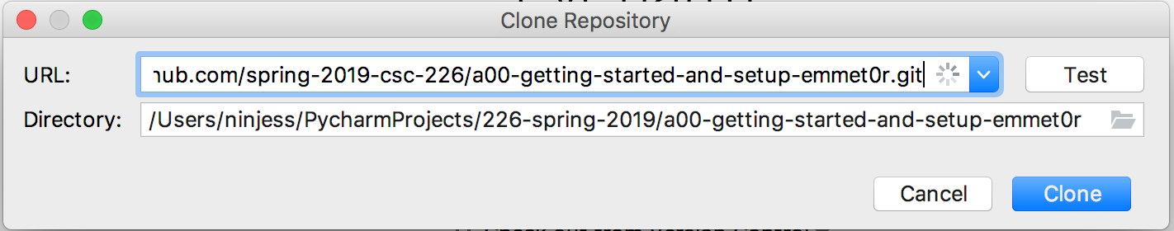

Next, let’s edit the README.md file so we can learn how to make changes using git. Open the file in PyCharm and make the following changes:

* Add your name to the file
* Add your Github Repository link
* Add a link to this document. To get that link, click the “Share” button in the top right of this document, and then click the “Get shareable link”.
* If you installed the Markdown plugin, you will see a nicely formatted preview of your README file. More on that soon!

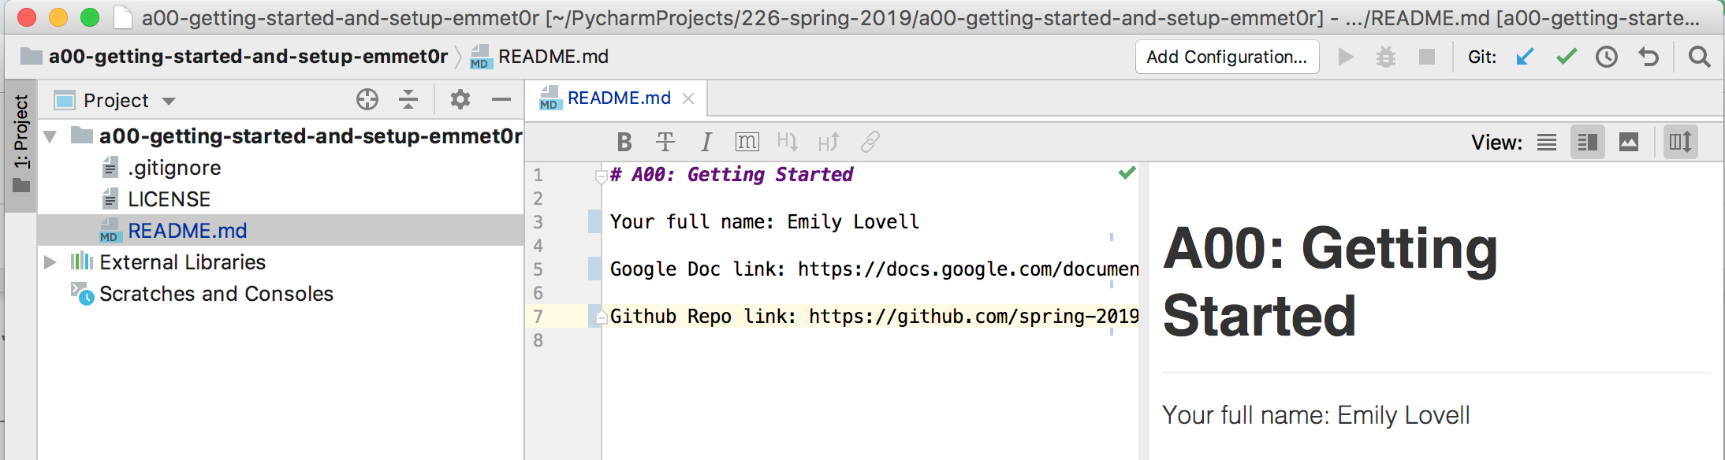

Changes you make to the local repository (i.e., PyCharm) are not official until they’ve been **committed** and **pushed**. Committing code is a way of marking important points when coding. Often, commits are made when a small piece of code is working, and you want to mark that point so you can get back to it later. Commits always come with a commit message; the better the message, the more valuable it is. Commit messages like “Fixed a bug” are usually not helpful; a better message would be something like “Added a function to correctly calculate the area of a heptagram”. After you’ve made a commit (or, often, many commits), and you want to make your code a part of the Github repository, you’re ready to **push**. Pushing often happens when a feature is complete, such as an entire assignment. We are ready to both commit and push your changes to the README.md file.

Right click the README.md file in the Project pane of PyCharm (far left), and click Git >> Commit File...:

Right click the file, and select "Git"

Add a meaningful commit message, then click “Commit and Push” in the bottom right:

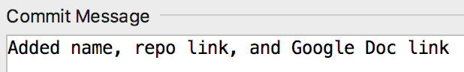 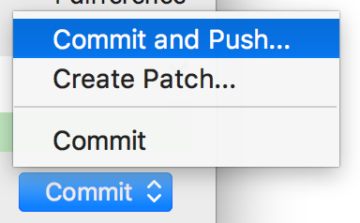

Click the “Push…” button on the screen that follows. Once you’ve pushed, you’ll notice your changes now appear in Github, back at the link from Question 5 (open it in a browser to check).

### Task 8: Help Us Get to Know You

Your last task is to help us learn a bit about you. Go to the following shared [Google Doc](https://docs.google.com/document/d/1qLc-MlCxqVPyxDw6w3JsAAWpalXKHtFy3m7xAYkx_Cc/edit?usp=sharing). Follow the instructions in that document, including adding a photo of yourself.

Some more information about yourself that we’d like to know:

|  |  |
| --- | --- |
| Your Full Name: | Thomas P Brown |
| Your Preferred Name: | Thomas |
| Berea Username (e.g., lovelle): | brownt2 |
| Advisor: | Dr. Meta Reyes (I have two) |
| Intended Major(s): | Biomechanical Engineering, Biomed |
| Expected Graduation Date: | May 2022 |
| Gmail address: | infinitemasskick@gmail.com |
| GitHub username: | The Giant Oof |
| Have you written code before, using a language such as Python, HTML, Javascript, or any others? If so, list them here. | 6.a. Only a little bit with Java and python I believe. |
| What do you hope to learn in this course? | 6.b. To perfect my coding skills |
| What are your primary reasons for taking this course? | 6.c. I am interested in taking this class and it will be beneficial for my career goals |
| What do you like about computers? | 6.d.How complicated the system |
| What do you dislike about computers? | 6.e. One small mistake can affect a computer w |

## Recap

|  |  |
| --- | --- |
| A lot was done in assignment A00. Let’s see how much you remember. | |
| What are we using Google Drive for in this course? | 6.a. To save and share our documents. |
| What are we using Git for in this course? | 6.b. Too allow everyone to see our repositories. |
| Where is the official agenda, including all due dates? | 6.c. The Syllabus but on trello is the actual site. |
| What does PyCharm allow us to do? | 6.d. It allows us to work with programming and coding, and creating projects and committing by hitting push. |

## Submission Instructions

1. Review the requirements above to ensure you have completed everything that was required of you. All yellow boxes should be filled in.
2. Make sure Task 8 is complete, including your image in the linked Google doc; we will be using that to find your work and grade you. Check the **Share** settings for this document (top right). Set them to “Anyone with the link can view”. That is how we will be able to access this document to grade you:   
    

**If you were unsuccessful in completing any of the tasks above (especially the Git section, because we won’t be able to grade your assignment), reach out for help from the instructors or the TAs. Get help early so we can ensure you are able to use the tools needed to be successful in this course, even if it’s after the due date for this assignment.**